
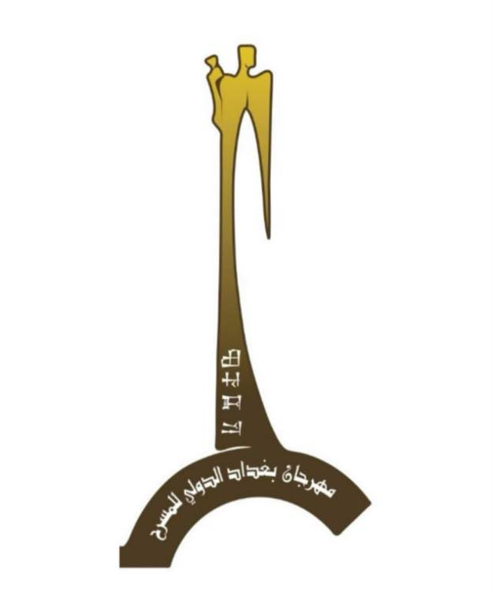

To all artists and theater groups around the world, to participate in the Baghdad International Theater Festival - Fifth Session 2024

Baghdad International Theater Festival \ 5th Session
For the period from 10 to 18 October 2024
Under the slogan "Because theater lights up life"
The Department of Cinema and Theater announces the opening of applications for the festival for all Iraqi, Arab and foreign theater groups wishing to participate in the activities of (Baghdad International Theater Festival in its fifth edition), which will be held for the period from 10 to 18 October 2024
at Baghdad theaters

play name

1 |  |  | The name of the play
2 |  | Country
3 | Author
4 |  |  |  | Director
5 |  |  |  |  | Language of the play
6 |  |  |  | Production Date / Enterprise
7 |  |  | Is there a translation file into Arabic?
8 |  |  | Contact Phone
9 |  |  | Contact the Scenographer
10 |  |  | Email
11 |  |  | Website
12 |  |  | Link to download and watch the play
13 |  |  | A link to download at least 5 photos with high quality. or send it via email
14 |  |  | A link to download photos of passports for all the team, in high quality. or send it via email

Other Information

Summary of the idea of the play from 100 to 300 words

Team Names

Sequence
Sequence | Name | Job in the band
1 |  |  | 1
2 |  |  | 2
3 |  |  | 3
4 |  |  | 4
5 |  |  | 5
6 |  |  | 6
7 |  |  | 7
8 |  |  | 8
9 |  |  | 9
10 |  |  | 10
11 |  |  | 11
12 |  |  | 12
13 |  |  | 13
14 |  |  | 14
15 |  |  | 15
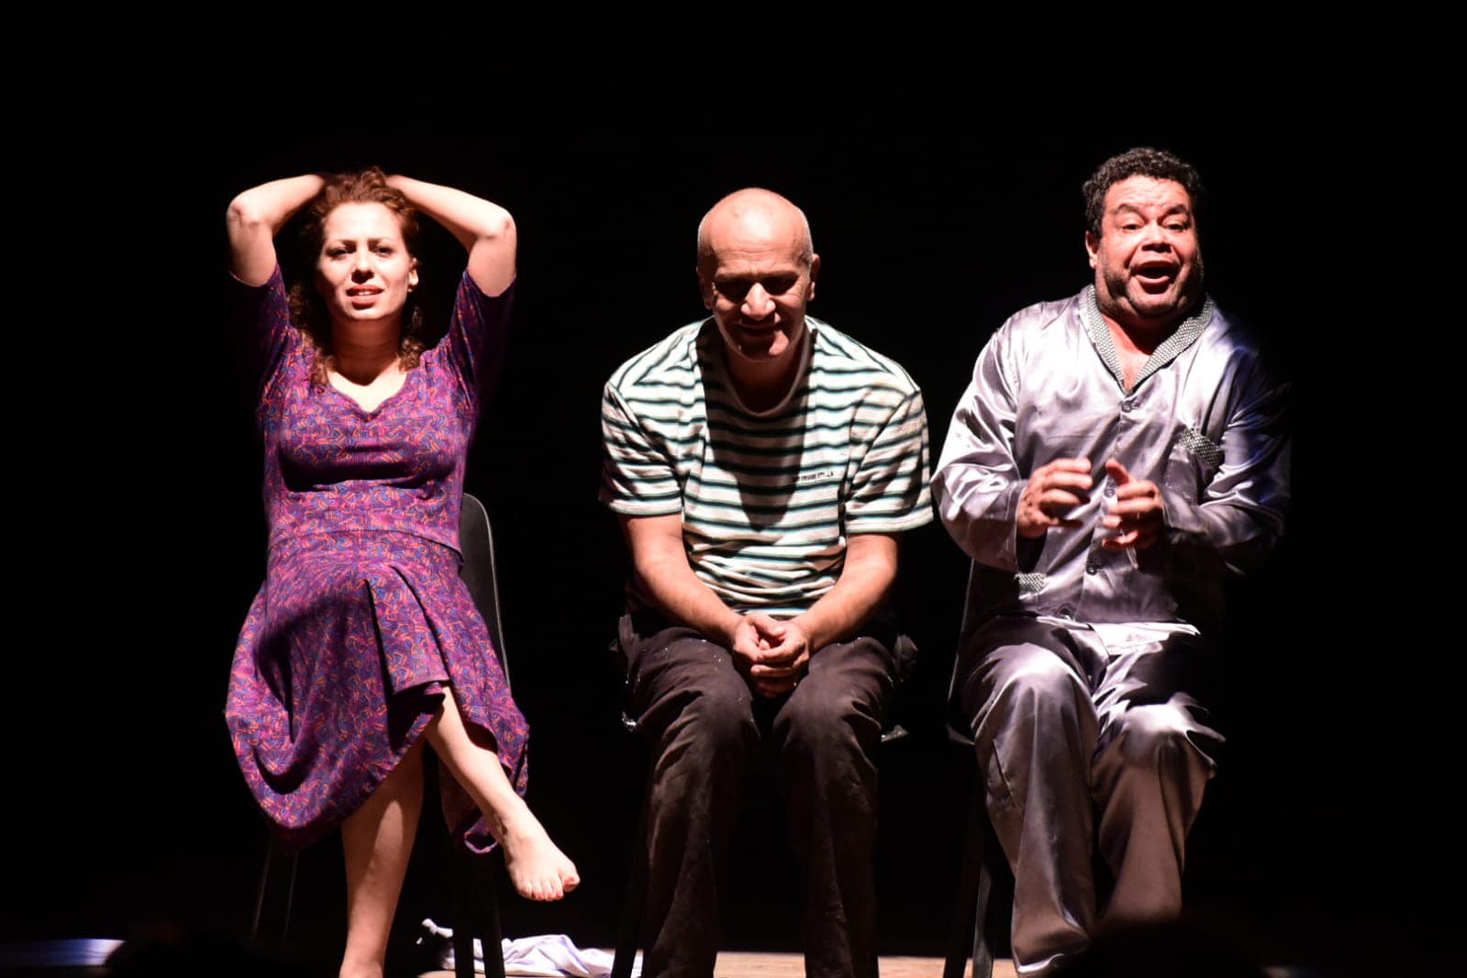

Passport Information
Important: remember the information as evidenced in the passport
Gender | Position | Expiration date | Passport number | اNationality | Country | Full Name
 |  |  |  |  |  |  | 1
 |  |  |  |  |  |  | 2
 |  |  |  |  |  |  | 3
 |  |  |  |  |  |  | 4
 |  |  |  |  |  |  | 5
 |  |  |  |  |  |  | 6
 |  |  |  |  |  |  | 7
 |  |  |  |  |  |  | 8
 |  |  |  |  |  |  | 9
 |  |  |  |  |  |  | 10
 |  |  |  |  |  |  | 11
 |  |  |  |  |  |  | 12
 |  |  |  |  |  |  | 13
 |  |  |  |  |  |  | 14
 |  |  |  |  |  |  | 15

Stage
1 |  | width |  |  | depth |  |  | Height |  | 1
2 | Stage type |  |  |  |  |  |  |  |  | 2
3 | Time it takes to install the décor |  |  |  |  |  |  |  |  | 3
4 | Time taken to dismantle the décor |  |  |  |  |  |  |  |  | 4
5 | Please send the type and number of devices required in the lighting |  |  |  |  |  |  |  |  | 5
6 | Please send the required device type in the audio |  |  |  |  |  |  |  |  | 6
7 | Other requirements |  |  |  |  |  |  |  |  | 7

Technical file
1- Please send a detailed technical file with drawings, engineering drawings and appropriate illustrative pictures of the requirements for the implementation of the theatrical work, including decorations and accessories that are difficult to carry with measurements and type of materials.
2- Outline of the lighting plan in the theatrical performance
3- Any data, documents or details that help clarify the exhibition space and its technical and technical implementation mechanisms

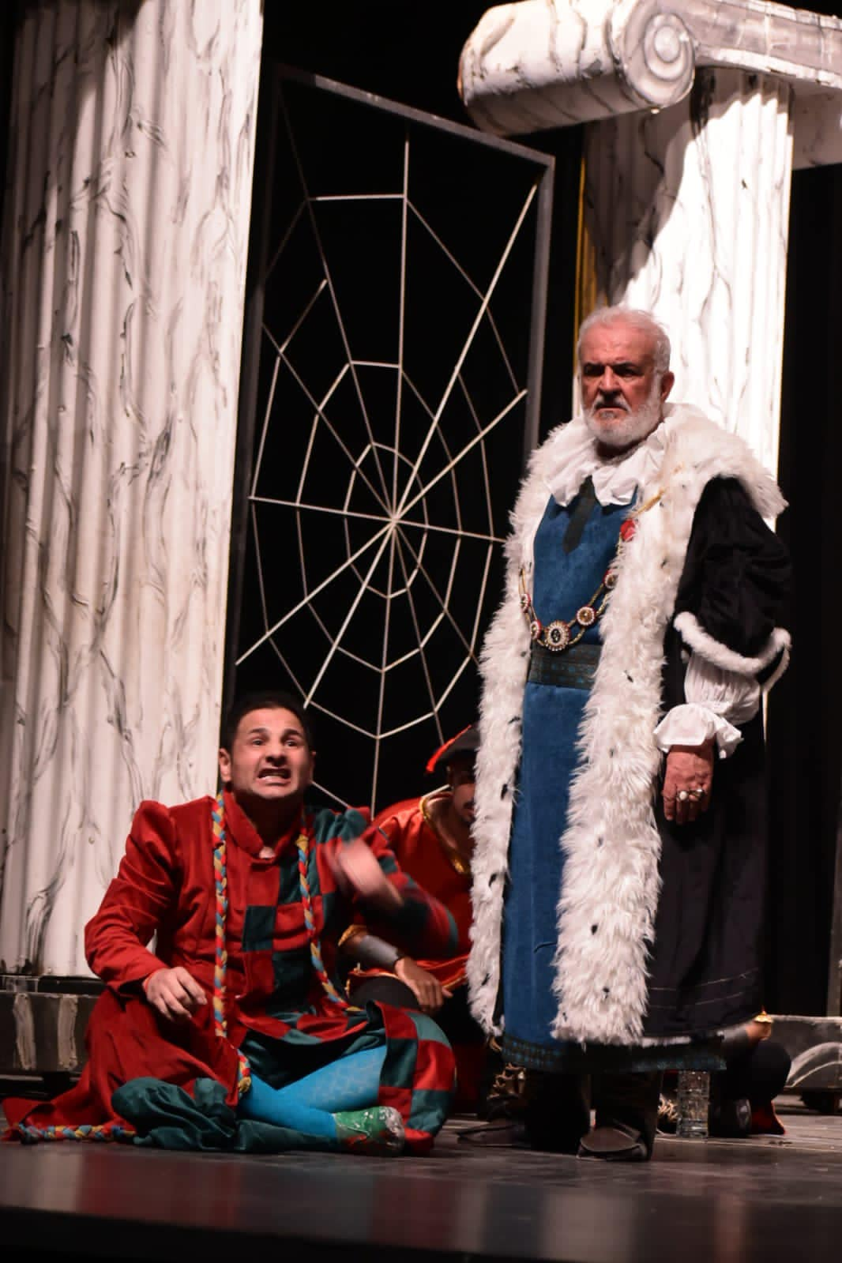

OTHER NOTES :
1- The festival receives Arab and foreign theatrical performances that were shown after (1/1/2023).
2- The festival does not accept monodrama plays, street theater, or children’s theater.
3- The festival does not accept works that violate the Universal Declaration of Human Rights or that bear contempt, contempt, sectarianism, or racist tendencies.
4- The band qualified to participate in the festival is committed to presenting two performances within the festival’s activities, according to what is programmed by the festival administration.
5- The troupe is committed not to make any changes to the theatrical work (with all its components) after announcing the play’s acceptance, and any violation of this clause exposes the play to non-acceptance.
6- The Arab troupes that qualify for theatrical works in colloquial or local dialect are committed to providing the audience with summaries written in classical Arabic, which contribute to facilitating the reception of the show.
7- The band that qualifies for the festival is committed to participating in conferences and seminars related to its work according to a program determined by the festival administration.
8- The troupe allows the play to be recorded on video for the benefit of the festival and for archiving purposes
9- We confirm that the festival does not bear any additional costs except what is mentioned in the attached official invitation.
10- We confirm that the festival is based on the competition system and the prizes are financial.

11- The number of the team participating in the festival consists of a maximum of fifteen people, and anything more than that is borne by the participating party
12- Sending a copy of the play text translated into English for Arabic performances and a copy translated into Arabic for foreign performances
13- Participating teams are bound by the dates and locations of the performances according to the schedule determined by the festival administration.
14- The deadline for receiving the participation form is July 15, 2023.
15- Fill out the form and send it to the email below. It is preferable to send it in Word format with the stamped copy.
16- You must ensure that the passports are valid before sending the file.. The file will not be received if it does not fully meet the required conditions.

E-mail : baghdaditf@gmail.com

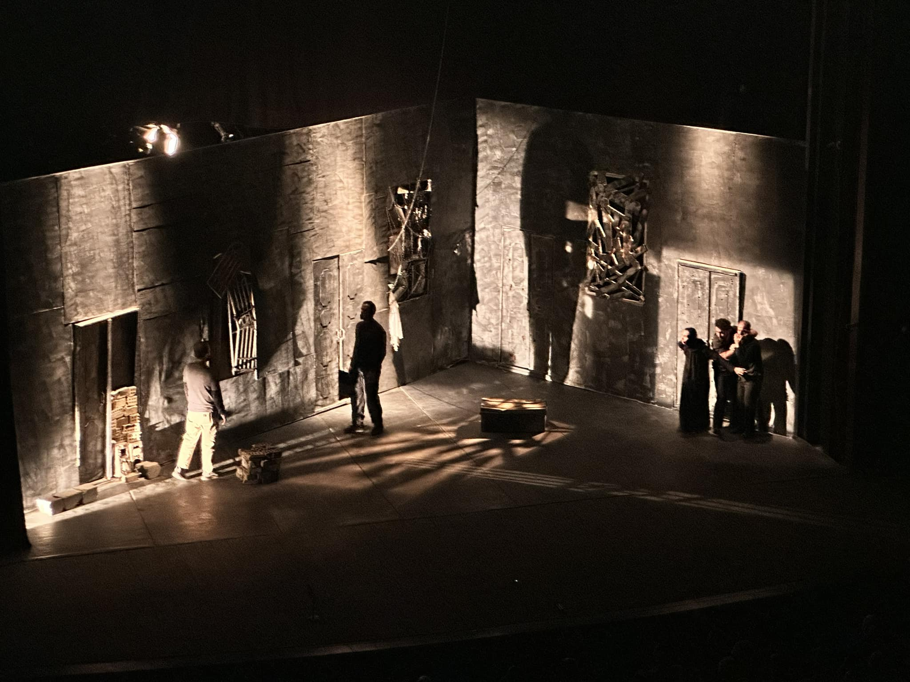

Pledge

I am ................................ the manager of a theater group... ............... for a band ........................... from the country of ..... ....................
I pledge that we will adhere all the terms and conditions set by the festival administration.
Signature: : Date:

HATEM OUDAH
Director of Festival
Theaters manager

JABBAR JODI
President of the Festival
Director General of the Department of Cinema and Theater

